Reducing Health Disparities in Africa and Around the World

The Global Telehealth Network (GTN), IEEE Smart Village (ISV), Healthcare Alliance for an Equitable World (HAEW) and Rotarians are collaborating to improve access to healthcare in medically underserved areas and to improve education and economic development in rural communities.
Our initial pilot programs in East Africa are designed to
- Improve maternal and child health services and control communicable diseases such as HIV, HPV and malaria
- Help to diagnose, treat and prevent non-communicable diseases, such as hypertension, heart, lung and kidney diseases, cervical & breast cancer, etc.
- Assist efforts in health promotion and disease prevention
Our long-term objectives are to reduce health disparities and inequities, and to advance progress toward many of the United Nations Sustainable Development Goals (SDG) to reduce or eliminate poverty throughout the world.
THE PROBLEM
Most countries in Africa have inadequate numbers of health workers to meet the needs of their populations, especially in rural areas, where nearly all care is provided by nurses with minimal support from physicians. Outside major cities, there’s little access to consultations by medical or surgical specialists.
Shortages are especially severe in maternal and child health, non-communicable diseases and mental health services.
40% of people in Sub-Saharan Africa live in extreme poverty, but their conditions can be improved with access to quality healthcare, education and economic development.
THE PLAN
The nonprofit Global Telehealth Network (GTN) was founded on the belief that no one should be denied access to healthcare because of their location, social status or ability to pay.
GTN recruits volunteer physicians and psychologists who offer free, real time, online video consultations for health workers in underserved areas when they encounter patients with complicated health problems. Physician volunteers with Healthcare Alliance for an Equitable World provide initial online evaluation and triage, with referral when needed.
GTN is helping to develop telehealth networks in each country, so doctors to obtain in-country specialty consults, while also allowing them to supervise nurses in remote areas. Meanwhile, GTN’s international panel of professional volunteers can fill any gaps in expertise with 24/7 availability.
IEEE Smart Village (ISV) provides seed funding and training
for local entrepreneurs whose for-profit social enterprises can develop solar power installations to provide clean, sustainable
electricity. ISV can also establish broadband Internet access for hospitals, clinics, schools and villages. Electric power and Internet connectivity allow access not only to telehealth, but also to resources for education and economic development.

OUR APPROACH
Our interventions are anchored on a Community-led Development model that puts communities at the front and center of the design, implementation and evaluation of our programs. We work with community and government leaders, entrepreneurs and non-governmental organizations (NGOs) that can assist communities in assessing their needs, then customize and implement solutions to meet those needs.
Our nine pilot programs in Kenya and Uganda involve three hospitals, four rural health centres and two school clinics. Each site is unique, and outcomes analyses will inform development of models that can be adapted for many additional facilities around the world. Our initial efforts will benefit over 100,000 people, and as the programs scale across Africa and other continents, they will impact the lives of millions.
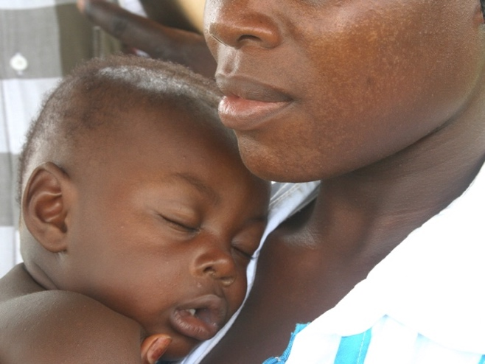
Installations at schools will provide access both to telehealth and to a vast array of online resources for K-12 education, as well as programs for adult education and vocational training.
COLLABORATIONS & SCALING
To implement the pilot programs at these nine sites, GTN, ISV and HAEW are collaborating with
- Movement for Community-led Development
- Child Health & AIDS Prevention (CHAP)
- Rotary Club of Los Altos, California
- Rotary Club of Cupertino, California
- Rotary E-Club of Silicon Valley Smart Village
- Rotary Clubs of Milimani and Busia, Kenya
- Rotary Clubs of Mengo and Kololo-Kampala, Uganda
- Three other Rotary Clubs and many other organizations
We plan to scale these efforts through additional programs in Kenya and Uganda, as well as in Liberia, Nigeria, Rwanda, Tanzania, Ghana, the Philippines, Vietnam, underserved areas of the U.S. (including urban free clinics and rural Tribal Lands) and eventually in other countries. We will also offer services to refugee settlements, disaster areas and conflict zones.
Contact: Jack Higgins, MD – jhiggins@globaltelenet.org
Global Telehealth Network – www.globaltelenet.org

